

**THE UNIVERSITY OF TEXAS AT DALLAS**

**PROJECT PLAN**

Danny

Scott

Trevor

Vaibhav

**ADVANCED SOFTWARE ENGINEERING PROJECT**

**SPRING 2015**



Document Revision History

|  |  |
| --- | --- |
| Version | Date |
| 1 | January 25th, 2015 |



Table of Contents

1. Overview…………………………………………………………………………………………..Page 1
   1. Purpose, Scope and Objectives
   2. Assumptions and Constraints
   3. Project Deliverables
   4. Schedule and Budget Summary
2. Project Organization………………………………………………………………………….Page 2
   1. Roles and Responsibilities
3. Managerial Process Plan…………………………………………………………………...Page 3
   1. Start-up plan
      * 1. Estimation plan
        2. Resource acquisition plan
   2. Work plan
      * 1. Work activities
        2. Resource/Schedule/Budget allocation
4. Technical Process Plan………………………………………………………………….……Page 4
   1. Process model
   2. Methods, tools and techniques
   3. Infrastructure plan
   4. Product acceptance plan
5. Supporting Process Plan…………………………………………………………………….Page 6
   1. Configuration management plan
   2. Test plan
   3. Documentation plan
   4. Quality Assurance plan
6. Appendix Glossary…………………………………………….……………………………….Page 7
7. Appendix References…………………………………………………………………………Page 7



List of Figures

Figure 1 (Gantt chart)…………………………………………………………………Page 4

Figure 2 (Dev cycle)……………………………………………………………………Page 5

List of Tables

Table 1 (Estimation plan)………………………………………………………..……Page 3

1. Overview

***1.1 Purpose, Scope and Objectives***

**Purpose**

To develop a software application(CometRide) to enhance the efficiency & location tracking of the shuttle system at The Univesity of Texas at Dallas.

**Scope**

This application will be used by the citizens of UTD and can be extended to anyone who uses the on campus shuttle system.

**Objectives**

1. Develop a mobile application which can be used by students, faculty and other member’s affiliated to The University of Texas at Dallas to request shuttle rides in campus.
2. CometRide will be used to give the driver of the shuttle real time updates of members who wish to request a ride in the campus.
3. Citizens of UTD will be able to request a ride at any location (pre-defined shuttle routes) and see the location of the shuttle in real time.
4. This application is intended to work with existing smartphone of students which are equipped with GPS, have access to Network Data(3G/4G LTE) and running Android(4.1+).
5. Each shuttle will have its own dedicated smart phone/tablet running CometRide.

***1.2 Assumptions and Constraints***

**Assumptions**

1. Majority of the students and faculty have smartphones.
2. Customers are familiar with using a smartphone application.
3. Network data and GPS availability is 100% throughout The University of Texas at Dallas.
4. The driver of the shuttle is familiar with interacting with a smartphone application.

**Constraints**

1. Customers using this application must have a smartphone equipped with GPS, have access to Network Data (3G/4G LTE) and running Android (4.1+).
2. Each shuttle will have its own dedicated smart phone/tablet running CometRide also equipped with GPS, have access to Network Data (3G/4G LTE) and running Android (4.1+).



***1.3 Project Deliverables***

1. CometRide running on client smartphone (citizens of UTD).
2. CometRide running on driver smartphone/tablet (driver of the shuttle).
3. Implement the objectives stated in “*Objectives – 1.1 Purpose, Scope and Objectives*”*, Page 4, Project Plan document.*
4. Deliver a working prototype of CometRide within April 25th, 2015.

***1.4 Schedule and Budget Summary***

**Schedule**

CometRide is being built as a part of the Capstone project (Advanced Software Engineering Project – spring 2015) at The University of Texas at Dallas. This project is guided by our ***Professor, Rym Z Wenkstern*** and actively supported by ***Ph.D. student Mohammad Al Zinati*** (Multi Agent & Visualization Lab). Since the spring semester is for a period of 4 months, we expect to deliver it by April 25th, 2015.

**Budget**

Currently we do not see any expenditure as all of us have smartphones. But, for any unexpected expense which might arise in the future, we have a budget of 200$ for the whole team.

2. Project Organization

**Roles and Responsibility**

Program Manager: Manages the workflow, co-ordinates portfolios, over sees communication channels, agrees on requirements through customer feedback and is responsible for the final product and defines deadlines (makes sure the project in on track).

Software Design Engineer: Responsible for designing the application in technical terms.

Software Development Engineer: Responsible for implementing the application from the design.

Software Development Engineer in Test: Responsible for testing the application and to approve it for commercial use.

Site Reliability Engineer: Making sure the application meets and adheres to the Service Level Agreement defined by the project. Is also responsible for de-bugging any live issues which may arise after the application is pushed into production.

*Note: Roles are not static. They may change based on the situation but are limited to the above roles only.*

3. Managerial Process Plan

***3.1 Startup plan***

1. Project roles are determined.
2. Vision document.
3. Come up with a clear and elaborate requirements document.
4. Discussing the risks with associated stakeholders.

***3.1.1 Estimation plan***

|  |  |
| --- | --- |
| ***Product*** | ***Cost*** |
| *Microsoft Project* | *NIL* |
| *IBM Rational Doors* | *NIL* |
| *IBM Rhapsody* | *NIL* |
| *Java IDE & Junit* | *NIL* |
| *Smatphones & Laptops* | *NIL* |

***Table 1 (Estimation plan)***

***3.12 Resource acquisition plan***

1. All software needed for this project will be open – source. If they are proprietary, an open – source alternative will be adapted.
2. Since the team already has smartphones, we will use our own smartphones.
3. Since the team already has laptops, we will use the same for development.
4. Printing out documents will be done at the Open lab in the University.

***3.2 Work plan and schedule timeline***

1. **Conceptual Phase** – Vision document, Project Planning document
2. **Elaboration Phase** – Software requirement specification, software requirement analysis, software architecture and detailed design specificaiotn
3. **Implementation Phase** – Prorotype with integration of all involved components
4. **Transistion Phase** – Testing, Maintainence and Project delivery

***Figure 1***

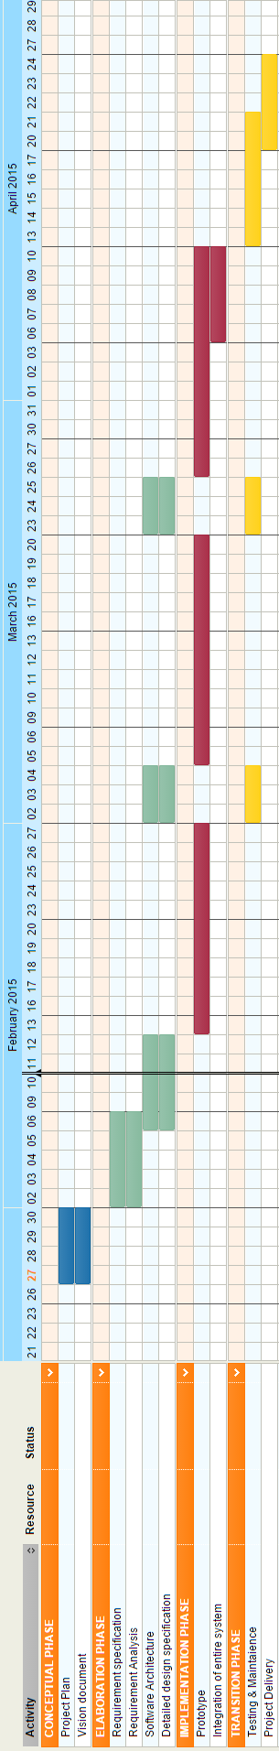

***(Gantt Chart)***

4. Technical Process Plan

***4.1 Process model***

We have planned to use the Unified Process which is a standard software engineering process and the agile methodologies to develop the Comet Ride. The reason why we adopted UP is that it’s use case driven, risk driven, architecture centric with iterative and increment development. We have planned to incorporate the agile terminologies into the UP iterations. By which each use case would be further divided into user stories which would be cataloged in the product backlog.

Each user story would undergo a RADIT (Requirement, Analysis, Design, Implementation, and Testing) process with a different emphasis for each depending on where the iteration is in the lifecycle. Since we meet up with the product owner every week we believe that a constant feedback loop would exist which would greatly support the agile methodology.

We have modified the daily meeting propaganda of the agile to our need to an alternate day meeting during which we plan and compile our works together. Other than these minor changes UP would still follow all its development cycle phases namely inception, elaboration, construction and transition.

The following picture describes the project model that we would be using for our product. As it could be seen, it’s the incorporation of agile into UP.

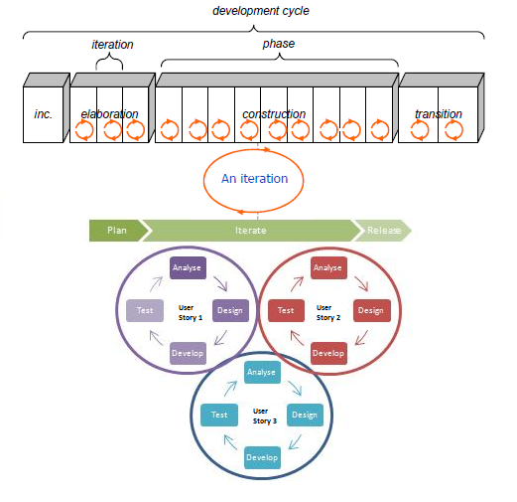

***­ Figure 2***

***(Dev cycle)***



***4.2 Methods, Tools and Techniques***

**Methods**

Comet Ride will be developed using Unified Process development method. For the implementation cycle alone we would be incorporating agile methodologies.

**Development Environment**

The product will be developed in a cloud environment from the UTDallas campus. The cloud provider shall ensure a high availability of service.

**Target Environment**

The product will run on a mobile based environment supported by android or iOS. For future development we are also planning to launch the application in the web platform as well.

**Techniques**

Comet Ride will be developed in an object oriented approach using Java. We plan to do the front end of the app using HTML5 and CSS3 so that it would be compatible across the android and iOS platforms. For real time mapping of the shuttles we have planned to use the geo-location service provided by Google.

**Tools**

We have identified the following tools which we would be using over the course of this project.

* Amazon Elastic Compute Cloud Environment
* Github – Version Control
* Jira – Test Management Tool
* Microsoft Office 2010 / Microsoft Project
* IBM Thapsody/ IBM Rational Doors
* Eclipse / JUnit
* Notepad++
* Ripple –Emulator
* Smartphones/Tablets

**Document Standards**

The standards that we plan to follow are the once outlined by the IEEE standards association. 

***4.3 Infrastructure Plan***

**Desktop setting**

All PC’s would use Windows 7 as its operating system and would be provided with all the tools furnished in 4.2.5

**Network setting**

All the PC’s would be connected to the high speed internet. The project files would be maintained in a shared Github repository so that they could be easily updated by all the members. The project documents would be maintained in a shared Google drive.

5. Supporting Process Plan

***5.1 Configuration Management Plan***

### Configuration Management Tools

We would be using “Github” as the configuration management tool. GitHub is a web-based Git repository hosting service, which offers all of the distributed revision control and source code management (SCM) functionality of Git as well as adding its own features.

### Configuration Status Management

We would be using “Jira” as a task board to keep track of who is working on which part of the system. By linking the git repository to the jira account we can keep track of who is working on which version of the system as well.

## *Documentation Plan*

The documents that would be developed during the lifetime of the project would adhere to the IEEE standards. The lists of documents that we are planning to maintain over the course of the project are

* Project Management Plan
* Project Vision
* Requirement Specification
* Design Specification
* System Architecture Document
* System Test Plan

We intend to update the above listed documents over different iteration as the requirement raises.

## *Quality Assurance Plan*

We plan to achieve the highest quality possible for each artifact. To ensure high quality several activities like code review would be conducted in a periodic basis to ensure this. Quality reviews done on documentation artifacts would ensure that they adhere to the standards on which they are based, and that non-documentation artifacts would adhere to the plans/designs laid out by their requirement. .Some of the quality attributes that are important to our project are

**Availability**: The cloud service provided by the service provider has a high availability rate which would give the app real time data.

**Usability**: The app will provide the user with information like wait time and request shuttle with the click of a single button

**Performance**: The app shall provide the user with data within 3 sec it has been requested for.

6. Appendix Glossary

1. UTD – The University of Texas at Dallas
2. IBM – International Business Machines
3. GPS – Global Positioning System
4. LTE – Long Term Evolution

7. Appendix References

1. Wensktern, R. Z. “Project Plan outline, Project Plan”, Advanced Software Engineering Project, eLearning, Spring 2015, The University of Texas at Dallas.